Admin test case:

Add a new user

Default:

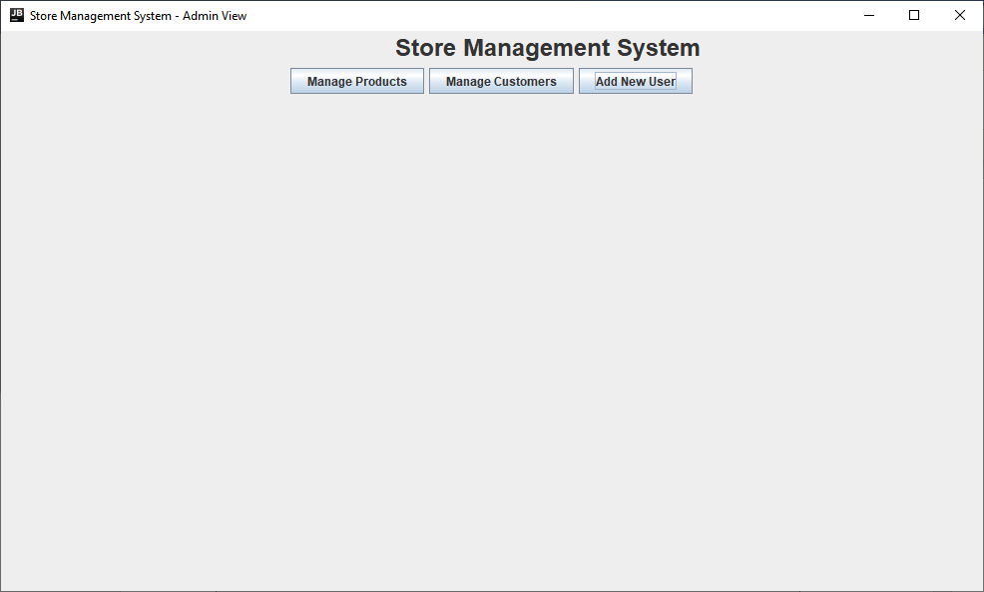

Clicking add new user:

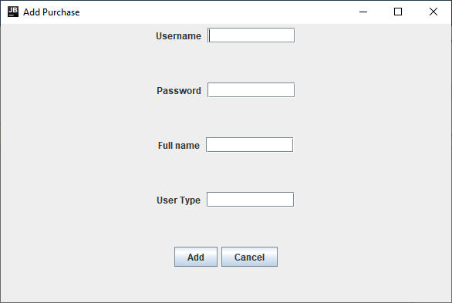

Inputting information and clicking add:

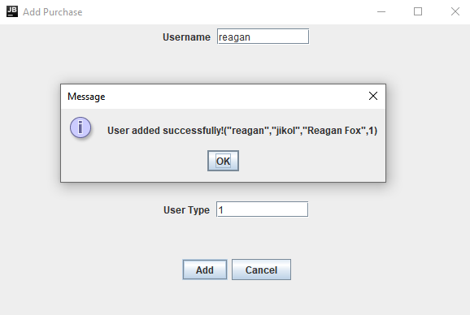

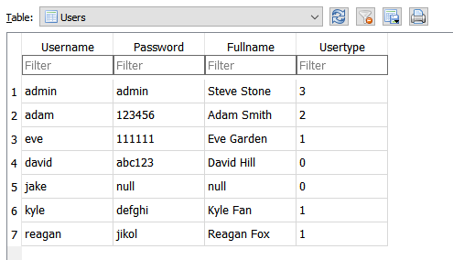

Admin also is able to manage products and customers.

Manager test case:

Add/update current product

Default:

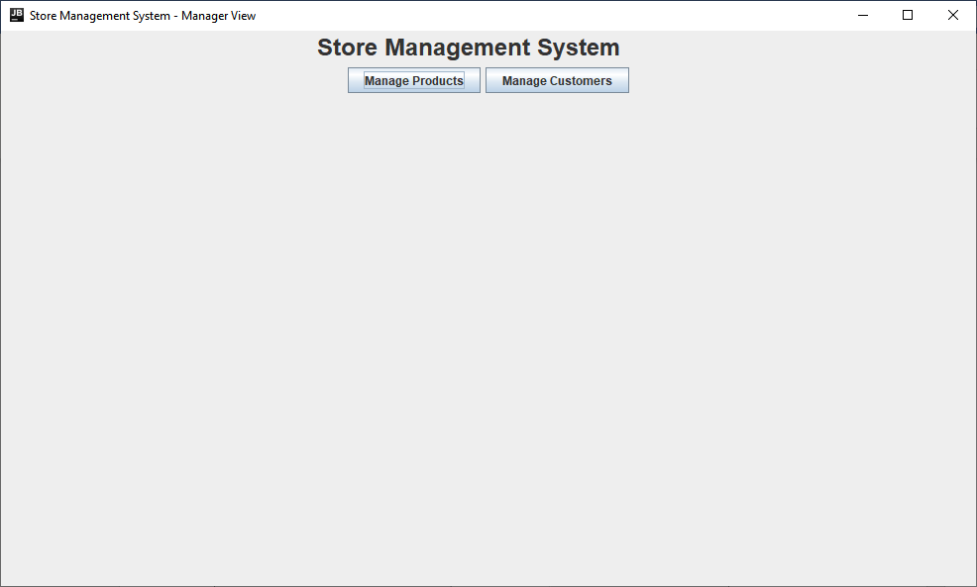

Clicking manage products and typing in product ID and then clicking load:

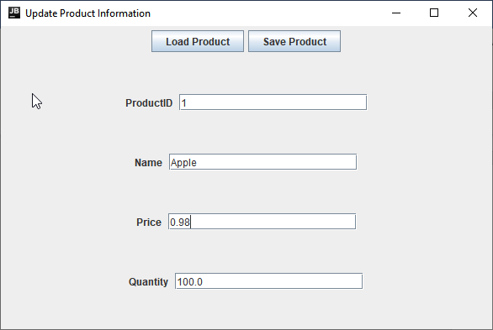

After updating info and clicking “Save Product”:

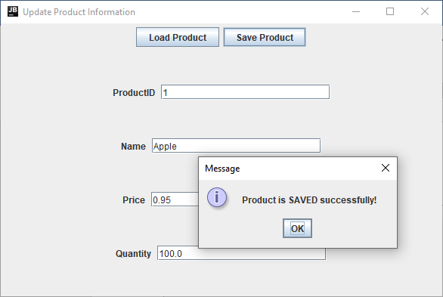

Cashier test case:

Add new customer or update a current customer:

Default:

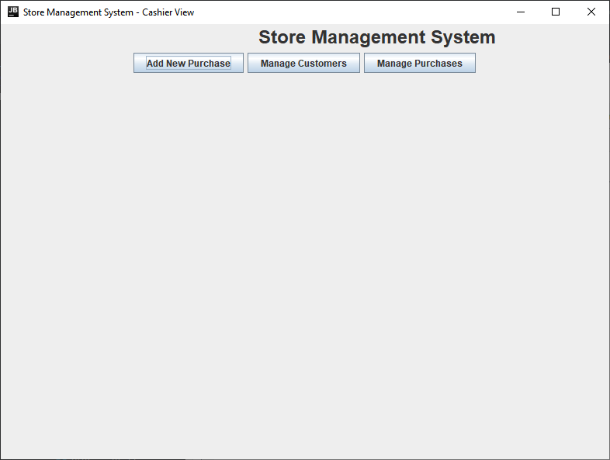

After clicking Manage Customers and typing in customer ID and clicking “Load”:

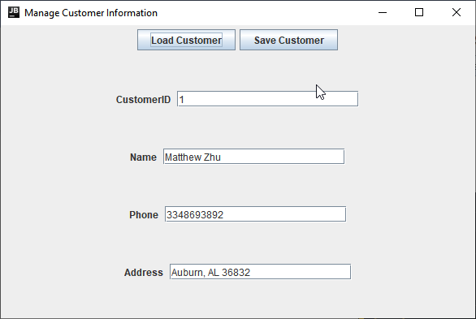

After changing desired values and clicking “Save Customer”:

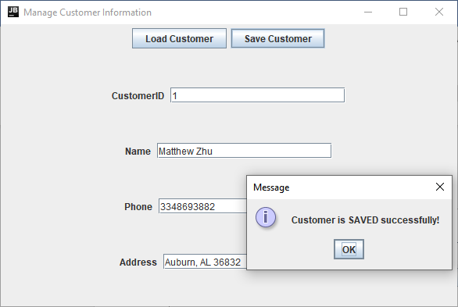

Add new purchase or update current purchase:

Default:



After clicking “Add New Purchase” and inputting the info and clicking “Add”:

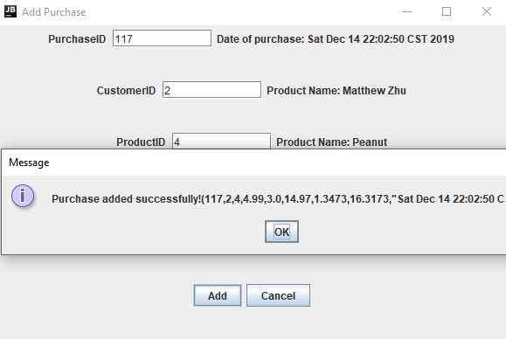

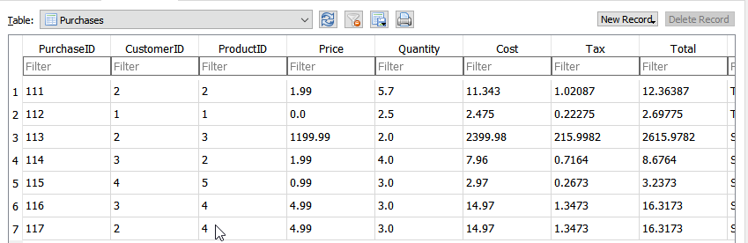

Customer test case:

New Purchase:

Default:

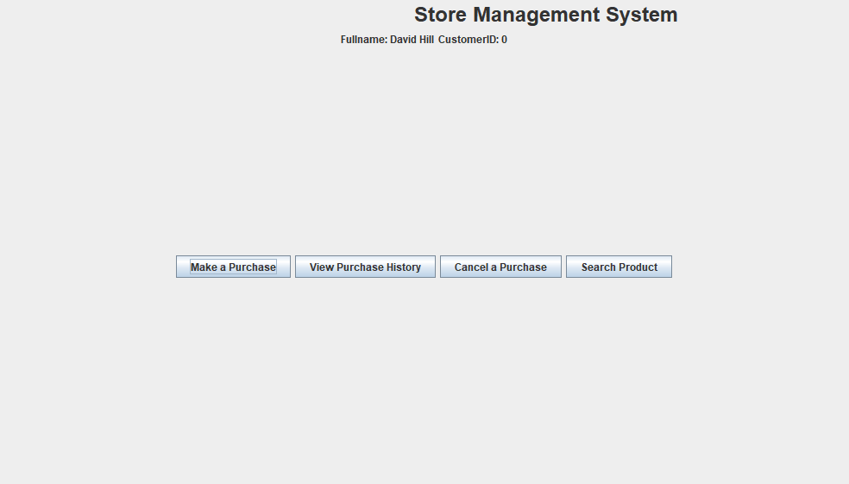

Inputting information for purchase after clicking “Make a purchase”:

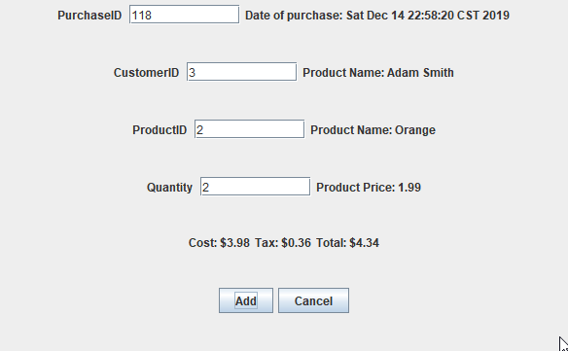

Clicking “Add”:

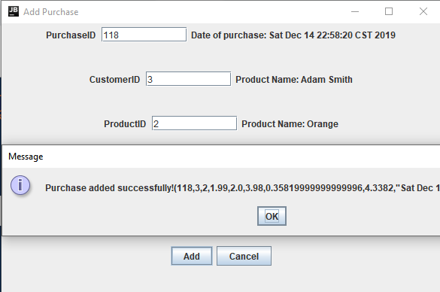

View Purchase History:

Default:



Purchase history display after clicking “View Purchase History”:

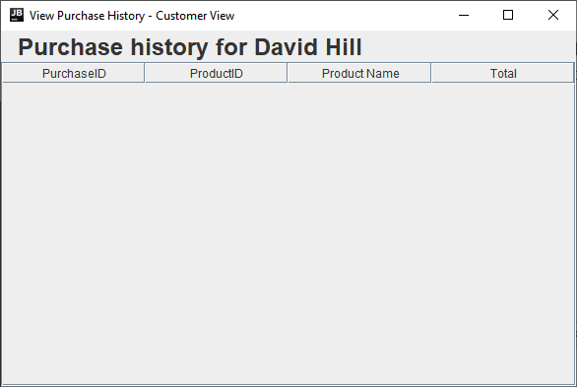

Search for product info:

Default:



Product search displayed after clicking “Search Product”:

